

**Visual guidance**

**Manual guidance**

**Mechanical guidance**

**Verbal guidance**

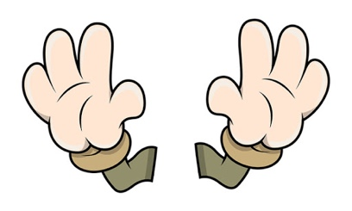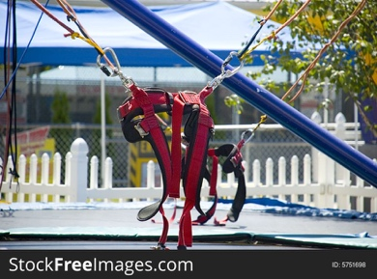

*You must also add notes on advantages and disadvantages of each type and use of guidance*