**Inverted U theory**

Definition of **Arousal**

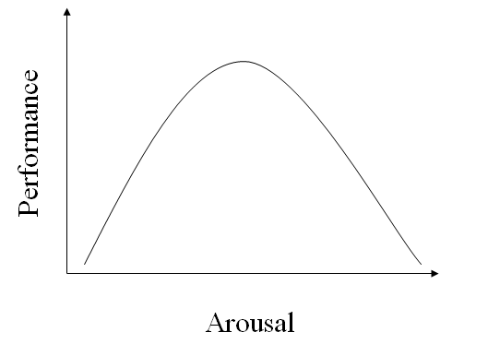

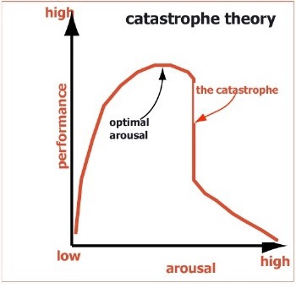

**Catastrophe theory**

**Drive theory**

**Drive theory**